User Manual
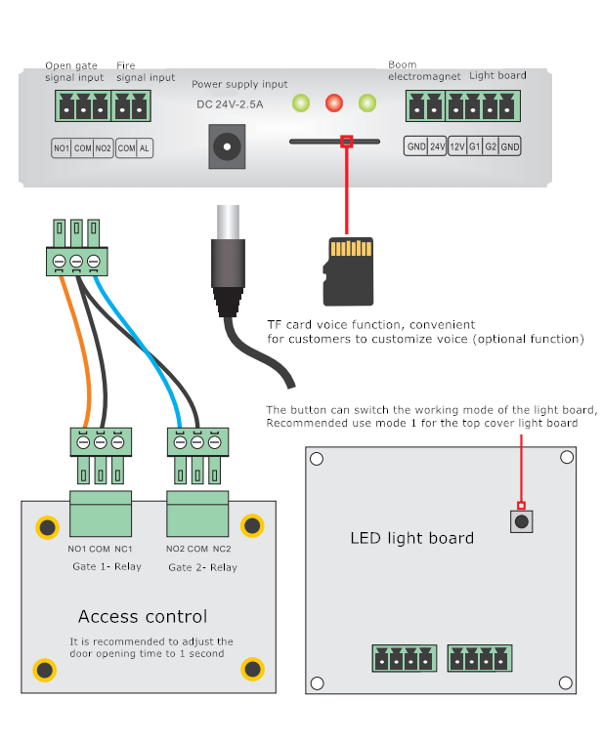
Function description of drop rod for fire
1. Short-circuit COM and AL, the pendulum rod will automatically drop, and the left and right bidirectional traffic indicator will light up.
2. When the short-circuit connection is maintained, the electromagnet of the boom fails, and the boom cannot be rise.
3. After the short circuit is released, the boom electromagnet becomes valid, and the boom can be manually lifted and the system returns to the normal working state
DIP switch function description
Setting table of waiting time for door opening
S2 | S3 | Second
OFF | OFF | 3
OFF | ON | 6
ON | OFF | 9
ON | ON | 12

S1: Memory function switch (default closed)
Open state: N people swipe the card N times consecutively, N people pass continuously
Closed state: N people swipe the card N times consecutively, only 1 person passes
S2 and S3: Binary switch sets the waiting time for door opening, please refer to the above table for details, the default is 6 seconds.
Automatic burn-in test and debugging
1. Keep COM and AL disconnected
2. Plug in the power supply to power the motherboard. At this time, all indicators will remain lit for 5 seconds. During this period, short-circuit COM and AL, and then release
3. In this mode, the limit sensor is invalid and the turntable can rotate freely
4. The automatic aging test mode can be released after power off and restart
Troubleshooting
Failure phenomenon | Reason | Solution
The red indicator light is off, mainbaord is not work | Overload or short circuit | Check whether the coil of the push-pull solenoid is compressed or penetrated by the screw, causing a short circuit  Check whether the wiring is correct and whether the terminal is stuck
Red indicator flashes continuously | Initialization of limit sensor failed | Check whether the sensor surface is covered by foreign matter  Check whether the sensor is blocked by internal wiring
After swiping card and passing , the green light does not go out and the turntable is not locked | Limit sensor does not work | Check whether the movement cover is installed correctly, wrong installation or tilting may cause the sensor to fail to detect the rotation of the turntable
Failed to pass continuously swipe card | Door opening delay of access control is too long | It is recommended to adjust the door opening delay of the access control system to 1 second

